**Syntax of touch command:-**

touch [OPTION] [FILE]..

**Explanation:-**

Touch command is used to change the timestamp. If we specify the file that does not already exists in your current working directory, then touch command will create new empty file.

For example,

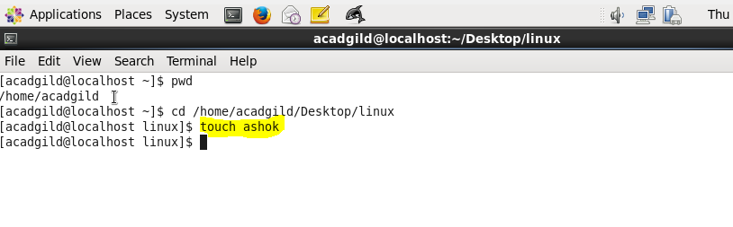

Here after running the above highlighted command, new empty file named **ashok** is created in that directory as mentioned in the below screenshot.

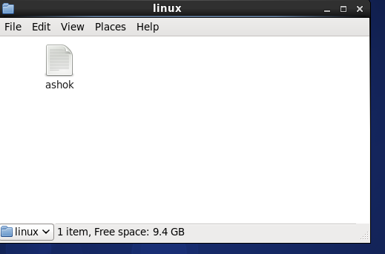

Now I have created additional file called student in the above directory to explain some basic options available in touch command.

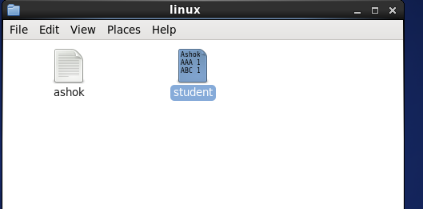

**Basic Option:-**

**touch** -**a:-**

-a in touch command changes the access time to current system time.

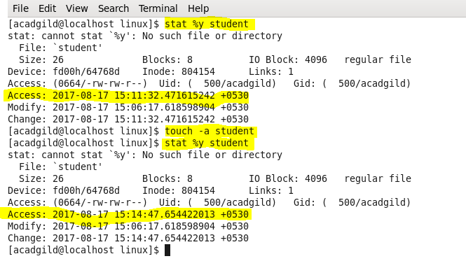

Here in the above screenshot, you can note the change in access time after using option –a in touch command.

**touch –m:-**

-m in touch command changes only the modification time to current system time.

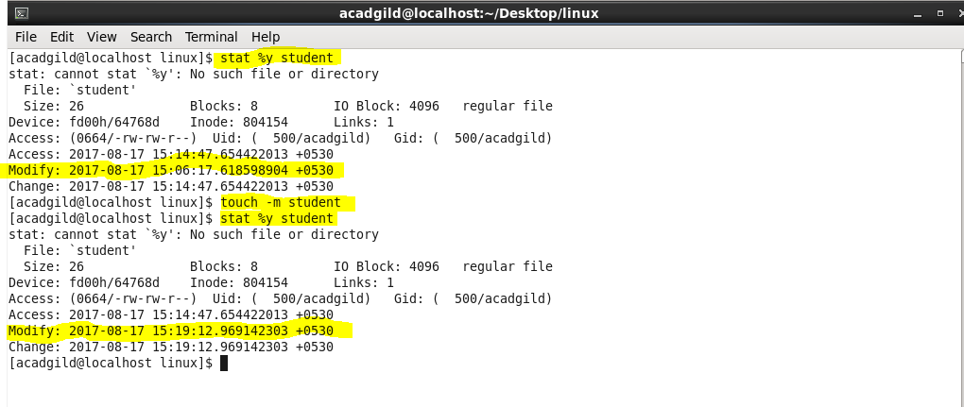

Here in the above screenshot, you can note the change in modification time after using option –m in touch command.

**touch –am:-**

-am in touch command changes both the access and modification time to current system time.

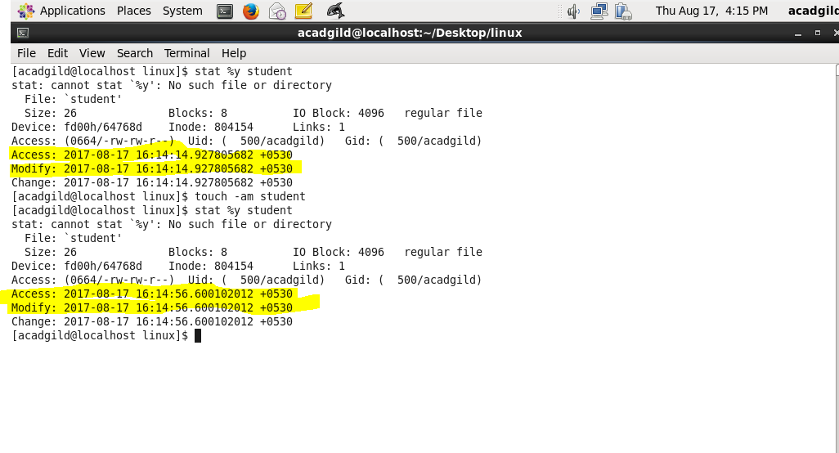

Here in the above screenshot, you can note the change in both access and modification time after using option –am in touch command.

**touch -r:-**

It will change the reference of timestamp for one file with respect to other file.

If you run the command, **touch –r ashok student,** timestamp of student is changed to timestamp of ashok.

